**Novel Architectures for Big Data Analytics Lab 1: Redis Application**

**Mert Ozer**

**02/10/2017**

**Prerequisites:**

* Python 2.7
* Redis
* Redis-py package (<https://redis-py.readthedocs.io/en/latest/>)

**Usage:**

1. Create one redis-server and one redis-cli.
2. Subscribe to channels from redis-cli.
3. Run client.py file.
4. Enter book information when it is asked. (isbn, author, edition and title)
5. Look to redis-cli instance to see relevant messages.
6. (optional) To check if book exist, open another redis-cli, get your book by isbn, wait some seconds and then recheck the book. Take in mind that books expire in 115 seconds.

**Be careful**

Program is not case sensitive. (it is easy to lower it and solve the problem but I believe some abbreviations might be missed.)

**Outputs**

* Png files are in the attachment if you want to look closely.
* One Client listening channel **“harry potter”**
* One Client listening channel **“George”**

1. **Screenshot after entering these inputs.**

Please enter ISBN of the book **123456789**

Please enter edition number of the book **2**

Please enter author of the book **Mert Ozer**

Please enter title of the book **harry potter**

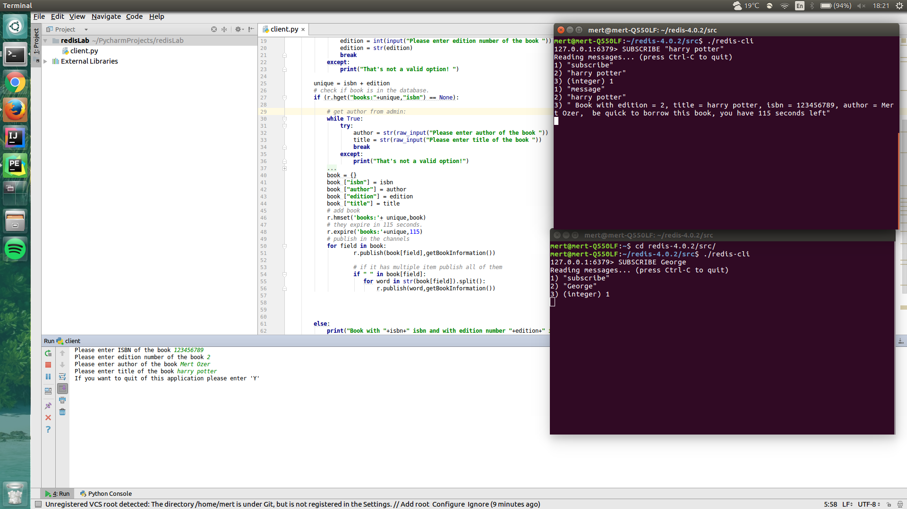

**(sc1.png)**

**2) After entering these inputs**

Please enter ISBN of the book **987654321**

Please enter edition number of the book **1**

Please enter author of the book **George potter**

Please enter title of the book **redis**

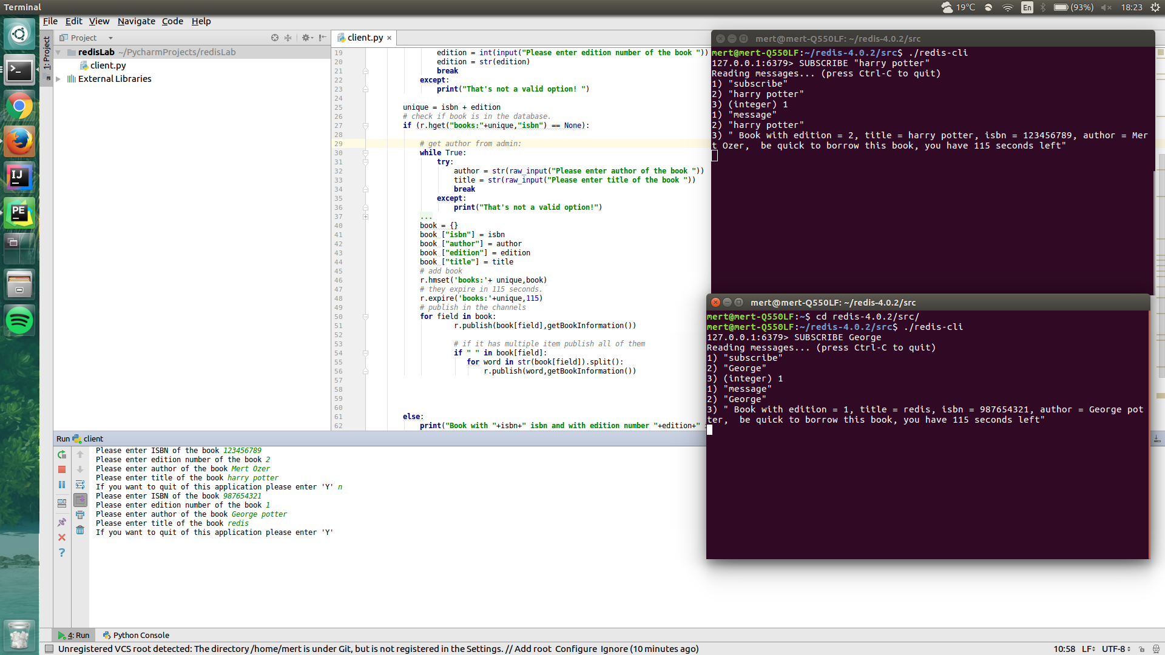

**(sc2.png)**

**So we can see that even the fields are parsed and published to their channels.**

**Created channels from example 2:**

987654321

1

George potter

George

potter

redis